DOCUMENTATION REQUIRED TO REGISTER
ALL ORIGINALS MUST BE PROVIDED TO SCHOOL BEFORE STUDENT CAN BE REGISTERED.

- Child’s Canadian Birth Certificate AND Care card or PR Card AND Care Card.

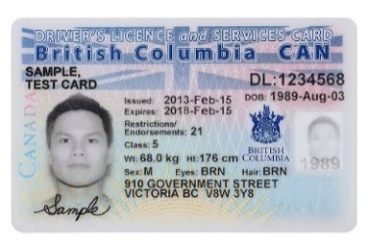
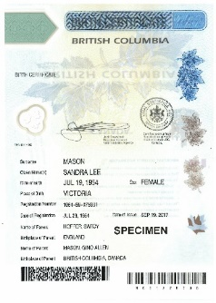

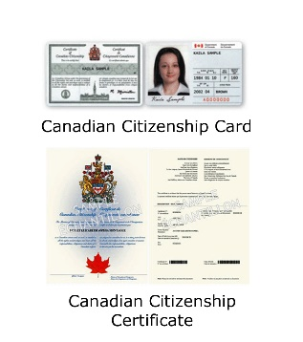
- Proof that one parent is a Canadian Citizen or Permanent resident. If parent(s) are on work permits/visa you need to email newtocanadaregistration@abbyschools.ca
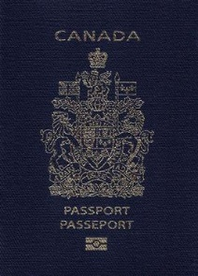
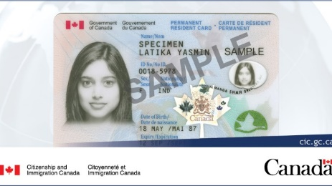

- TWO Documents Proving Address: ONE of the following -
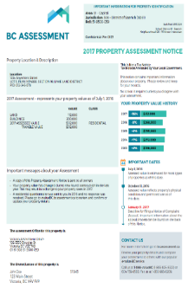
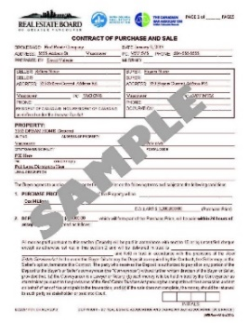
-Mortgage Document
-Property Tax/Assessment
-Legal Rental Agreement
-Statutory Declaration of residence signed by lawyer or notary
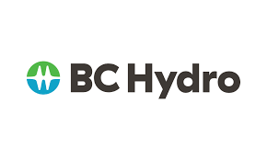
-Utility Bill

PLUS ONE OF THE FOLLOWING:
- Government document
- MSP Bill
- Child Tax Benefit
- Income Tax Assessment
- Most recent T4
- Vehicle Insurance
NO BANK STATEMENTS OR CREDIT CARD STATEMENTS

