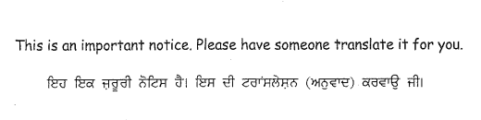
School Year 2022-23

Harry Sayers Volunteers,

As we move ahead with the current school year, I would like to take some time to help guide those of you interested in volunteering at Harry Sayers. Below is important information for volunteering at our school.

Name of Volunteer: ___________________________________Parent Email:_____________________

Name of your Child(ren):_______________________________ Grade Level (s):_______________

- Do you have a child at the school? Yes or No
- What is your purpose to be at the school? Field Trips? Coaching? Hot Lunch? PAC Events?

________________________________________________________________________

Checklist to complete for all Volunteers:

- All Volunteers must have a Criminal Record Check (CRC) completed at the School Board Office (SBO) prior to starting at Harry Sayers. To do so, please book an appointment to go in to the SBO to fill out the Volunteer Consent form and provide 2 pieces of valid ID.
email criminal.check@abbyschools.ca. Volunteer CRCs are free of charge. You will not be given a copy of the CRC nor does the school have a copy of it.

_____________check when complete Criminal Check Expiry: ________________________

_____________Initials of School Staff to confirm completion

- All staff and volunteers are required to read the Communicable Disease guidelines and complete the on-line training and quiz (SWAY training) prior to starting. A link to do so will be provided from Mr. Colbert once the CRC process has been completed.

_____________check when complete (confirmation sent to SBO when quiz completed)

_____________Initials of School Staff to confirm completion /training has been sent________

- Please fill out the Abbotsford School District Volunteer Form AP 416-2, 416-4 & School Letter

_____________check when ALL complete _____Initials of School Staff to confirm completion

I can confirm all the above is completed and volunteer is ready for the 2022-23 school year.
______________________
Ryan Colbert Principal

Thank you for your interest in volunteering at Harry Sayers Elementary. Should you have any questions, feel free to call the office at 604-852-9665 or email Mr. Colbert at ryan.colbert@abbyschools.ca.

Sincerely,
Mr. Colbert Principal Harry Sayers Elementary

