DOCUMENTATION REQUIRED TO REGISTER
ALL ORIGINALS MUST BE PROVIDED TO SCHOOL BEFORE STUDENT CAN BE REGISTERED.

- Child’s Canadian Birth Certificate AND Care card or PR Card AND Care Card.

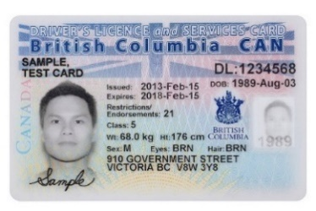
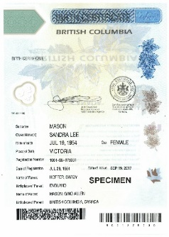

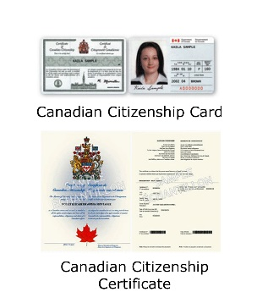
- Proof that one parent is a Canadian Citizen or Permanent resident. If parent(s) are on work permits/visa you need to email newtocanadaregistration@abbyschools.ca
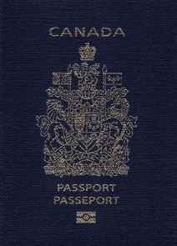
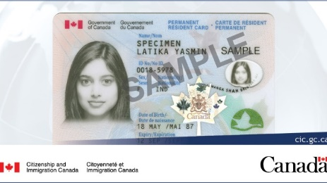

- TWO Documents Proving Address:
ONE of the following -
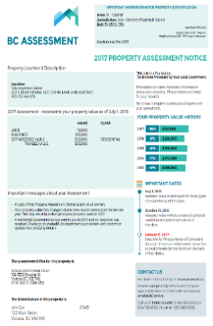
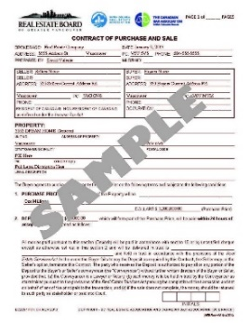
-Mortgage Document
-Property Tax/Assessment
-Notarized Statutory Declaration of residence
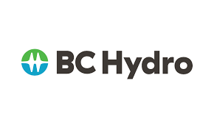
-Utility Bill in parents’ name (not in landlord’s name)


PLUS ONE OF THE FOLLOWING:
- Government document / CRA letter or document (no screenshot of CRA change of address form online)
- MSP Bill / BC Medical Services Plan invoice or statement
- Child Tax Credit document
- Income Tax Assessment
- Most recent T4 or pay stub from employer
- Vehicle Insurance (no driver’s licenses as proof residence)
NO RENTAL AGREEMENTS, BANK STATEMENTS OR CREDIT CARD STATEMENTS

